Accepting the dialog
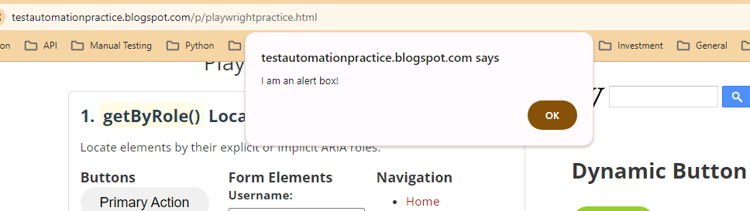

Dismissing the dialog
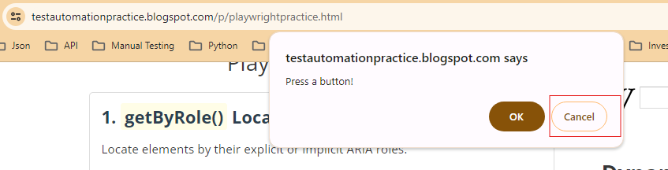

Entering the value in the Prompt Dialog, Getting default value and getting its type
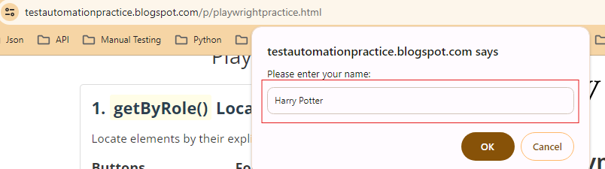

Method Name | Uses / Purpose | Example Code Snippet
accept() | Accepts the native dialog (simulates clicking the "OK" or "Yes" button). | dialog.accept();
accept(String promptText) | Enters text into a JavaScript prompt dialog box and accepts it. | dialog.accept("John Doe");
dismiss() | Dismisses or cancels the dialog box (simulates clicking the "Cancel" or "No" button). | dialog.dismiss();
message() | Retrieves the exact text message content displayed inside the dialog box. | String text = dialog.message();
type() | Returns the type of the dialog as a String. Returns: "alert", "beforeunload", "confirm", or "prompt". | if (dialog.type().equals("prompt")) { ... }
defaultValue() | Returns the default prompt value text or an empty string if none is defined. | String defaultVal = dialog.defaultValue();
page() | Returns the originating Page object that initiated or triggered the dialog box. | Page originalPage = dialog.page();

